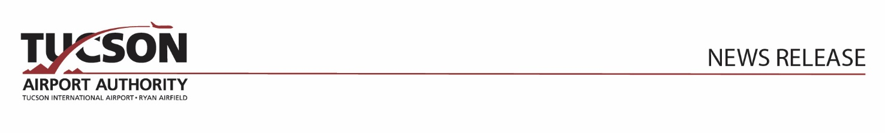

For Immediate Release November 14, 2024
Tucson International Airport Ranked #1 for Seat Capacity Growth

Tucson, Arizona – Tucson International Airport (TUS) ranks as the #1 airport for seat capacity growth among the top 30 airports in the western United States during the upcoming holiday season, leading with a 16.8% year-over-year growth rate during the 10-day period around Thanksgiving.

Seat Capacity Growth | Thanksgiving 2024 vs. 2023
TUS | 16.8%
Burbank, CA | 14.8%
San Francisco | 13.7%
Reno | 12.2%
San Jose | 12.2%
Sacramento | 11.2%
Phoenix | 10.6%
Portland, OR | 10.4%
Fresno | 8.5%
Ontario. CA | 8.1%
Colorado Springs, CO | 7.3%
San Diego | 7.0%
Boise | 7.0%
Denver | 5.5%
Salt Lake City | 5.4%

November marks a traditionally busy time for air travel and TUS expects 11% more travelers flying through TUS this Thanksgiving season, with roughly 137,000 passengers using the airport over the 10-day holiday travel period (Nov. 23- Dec. 2). December 1st will be the peak travel day with a projected 15,600 travelers and 69 daily departures.

Strong community support, by flying local has helped TUS attract larger aircraft and more flight availability to meet the needs of Southern Arizona.

Tucson International Airport (TUS)
TUS represents 1.5 million Southern Arizona residents. With more than 135,400 landings and takeoffs annually, TUS serves commercial carriers, military, business and general aviation. TUS offers nonstops and convenient one-stop connections to more than 400 cities around the world. Located in the heart of the Sonoran Desert, Tucson is the top destination to explore outdoor adventures and to experience a rich tapestry of flavors, culture and traditions.
###

TUCSON AIRPORT AUTHORITY: The Tucson Airport Authority (TAA) is an independent, non-profit organization with the responsibility to operate, manage and develop Tucson International Airport (TUS) and Ryan Airfield (RYN). The TAA receives no local tax dollars. It sustains operations from airport-generated revenues, like concessions, leases, and landing fees. The TAA invests millions each year in safety, security, and customer service for the benefit of travelers, tenants, employees, and the entire Southern Arizona region. The airport system supports nearly 46,000 jobs and contributes to more than $8.3 billion in economic activity.

