Please accept this complimentary parking pass for the third floor of the parking garage. Parking is available for you anytime you are at TUS for TAA Business or personal travel.
In order to enter the parking garage you will be required to present your proximity (prox) card to the reader. Directions to the garage and card reader instructions are found below.
If you have any questions regarding the use of the parking garage or need assistance with your prox card, please contact the TAA Police Department at 520-573-8111.

PARKING GARAGE DIRECTIONS
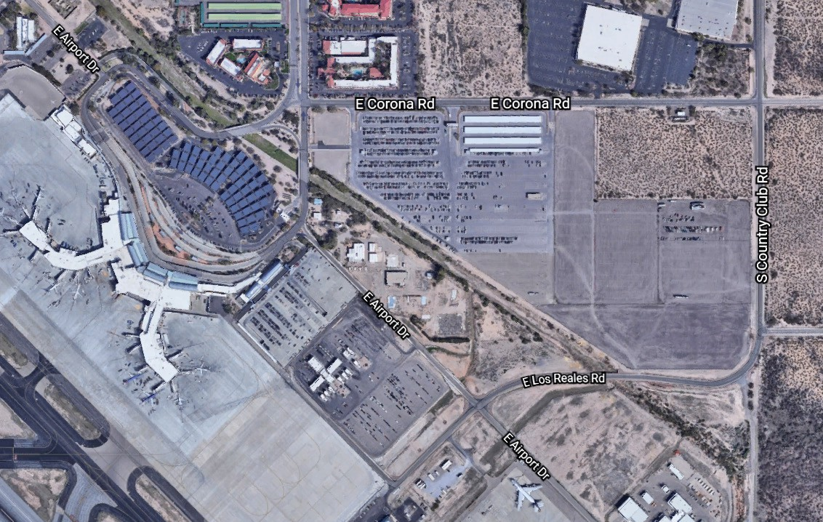
ENTER GARAGE HERE:
2508 E. Los Reales Rd.

ADDRESS: 2508 E. Los Reales Rd., Tucson, AZ 85756
From Tucson Blvd: Traveling south on Tucson Blvd. Turn left on Corona Rd. Turn right on Country Club Rd. And continue south following signs for garage parking.
From Country Club: Traveling south on Country Club Road, continue south towards the terminal. Follow the signs for garage parking.

TO ENTER THE GARAGE:
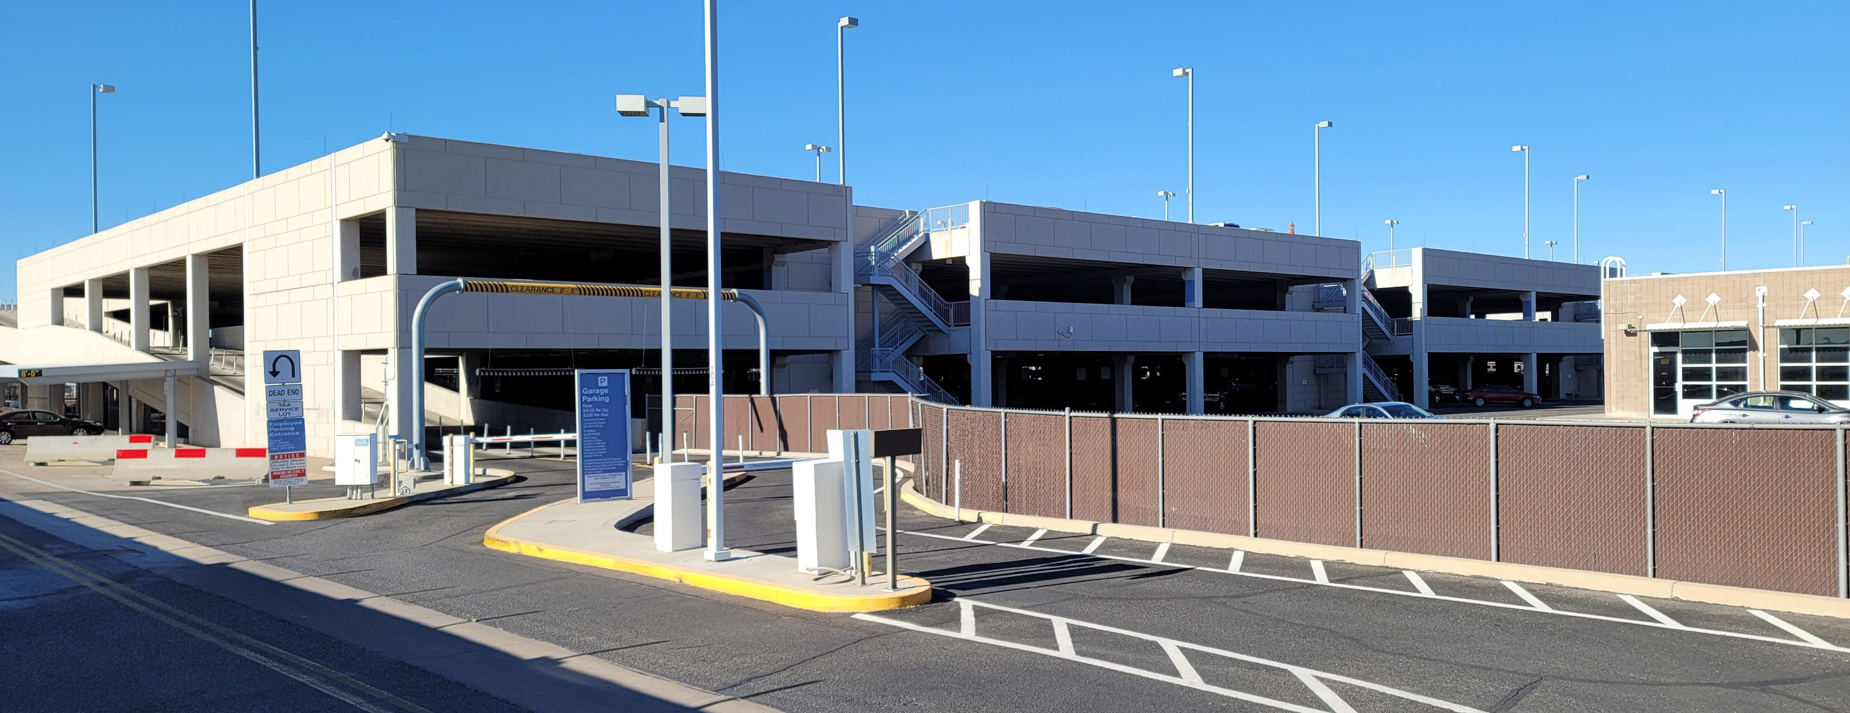
PUBLIC PAID
PARKING
TAA EMPLOYEE, AIRLINE EMPLOYEE AND TAA MEMBER
PARKING
GARAGE ENTRANCE
(LEFT LANE ONLY)

Approaching the parking garage entrance, enter through the left lane, which is the ‘TAA Employee,’ and the ‘TAA Member’ entrance. This lane will take you directly to the third level. If you elect to park on the 2nd Floor, you will be charged at the public rate for parking.

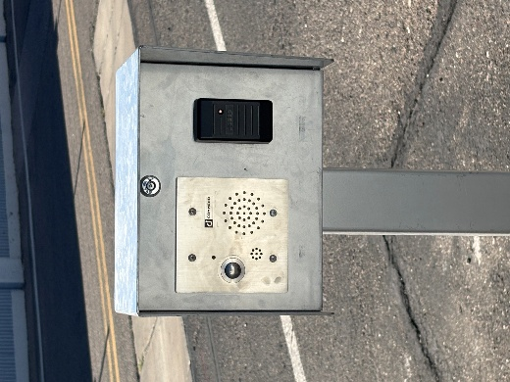
UPON ARRIVAL:

While in the left lane, present your TAA-issued proximity card to the card reader. The gate arm should open automatically. If for some reason the gate arm does not open, please try a second time to present your card to the card reader. If this does not open the gate arm, please use the intercom button for assistance. Once on the third floor, you may park in any available spot. You may choose to park on the second floor; however, you will be charged at the public rate for parking.

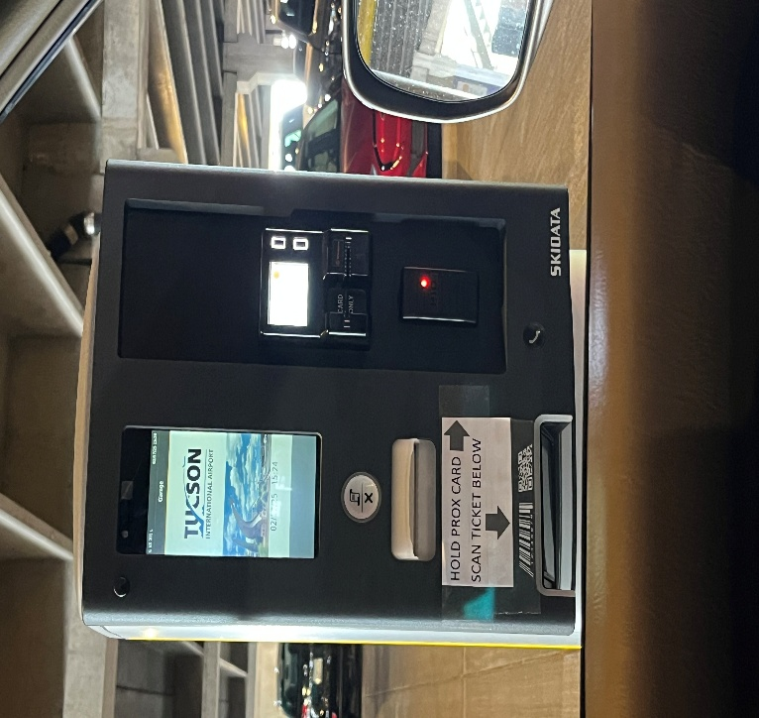
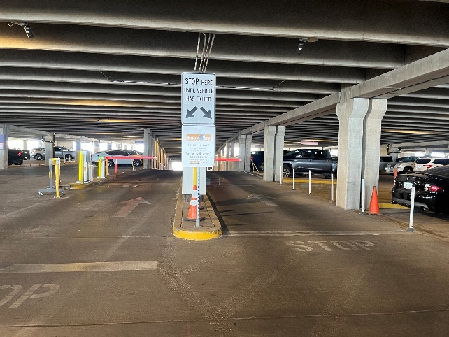
TO EXIT THE GARAGE:

To leave the parking garage, drive toward the center of the parking structure, and take the downward ramp. Prior to getting to the second level, you will be required to present your prox card.
Any TAA Employee or TAA Member vehicles parked in violation may be ticketed at the owner’s expense and will be charged the public rate for parking
Once on the second level, follow signage to the exit. You will be required to present your prox card, for a second time, to exit the parking garage. You are permitted ten (10) minutes between the third floor and the second-floor gate arms. You may exit using either lane.
If your proximity card fails to open the gate arm at either floor, please present your prox card a second time, and if that fails, please use the intercom for assistance.
Then proceed to follow exit signs to the fenced area onto Airport Drive.

